 | Assignment No. 1  Semester: Spring 2026  CS201P – Introduction to Programming(Practical) |  | Total Marks: 20  Due Date: 30th April 2026
Instructions
Please read the following instructions carefully before submitting the assignment:
It should be clear that your assignment will not get any credit if:

- Assignment is submitted after the due date.
- Submitted assignment does not open or file is corrupt.
- Assignment is copied (From the internet/students).
- Assignment is submitted in any file format other than .cpp.

Recommended tool to develop Assignment
- Dev C++

Objectives:
To enable students to understand and practice the concepts of:
- Variables
- Constants
- Data types
- Arithmatic operators
- Conditional statements
- Output statement
- Iterative stetments

Assignment Submission Instructions

You must submit only a .cpp file on the assignments interface of CS201P from your LMS account. Assignments submitted in any other format(image, pdf, doc, docx, rar, zip etc) will be scaled with zero marks. So, check your solution file format before submission.

For any query related to the assignment, please contact CS201P@vu.edu.pk.

Assignment

Problem Statement

Write a C++ program that performs a complete analysis of a student's VU ID. Your program must hard-code your own VU Student ID and name. Then the program will extract its numeric part and then perform a series of operations on the extracted digits including report of absent digits, even/odd digit reporting, finding largest and smallest digits, and printing the multiplication table of the largest digit.

Detailed Requirements

Step 1 –Digit Extraction and Reversal
Hard-code your full name and VU Student ID (e.g., BS123456789) directly in the program.
Display them as the first two lines of output.
No user input is taken anywhere in the program.

Extract the numeric part from your ID (0 to 9).

Display the numeric part digit by digit on the screen.

Also display the reversed form of the numeric part.

Step 2 – Report of absent digits

Report which digits did not appear in the ID.

Step 3 – Even and Odd Digit

Display all even digits found in the ID.

Display all odd digits found in the ID.

Step 4 – Largest and Smallest Digit

Find the largest digit and the smallest digit present in the numeric part of the ID.

Display both clearly.

Step 5 – Multiplication Table of the Largest Digit

Using the largest digit found in Step 4, print its complete multiplication table from 1 to 10.

If the largest digit is 0, display the message: "Multiplication table cannot be printed for 0."

Expected Output Format:

Your program should display output in a clear and organized manner, similar to the given Sample output:

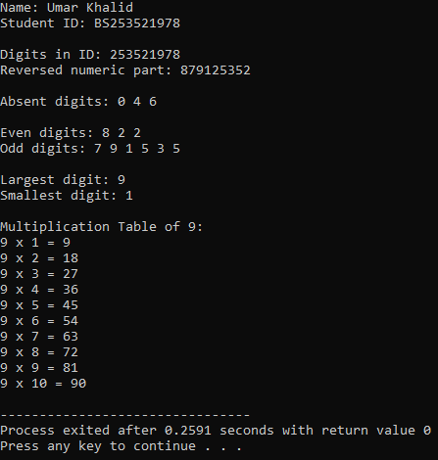

Syllabus:
The syllabus for this assignment includes all topics covered in first 3 weeks (lecture no. 1 to lecture no. 9).

Note: Remember that printf and scanf are not allowed. if you use it in the program, your marks will be deducted.
Best of luck!

